Is Jesus an Alien From Another Planet 2 of 3
July 19th, 2021

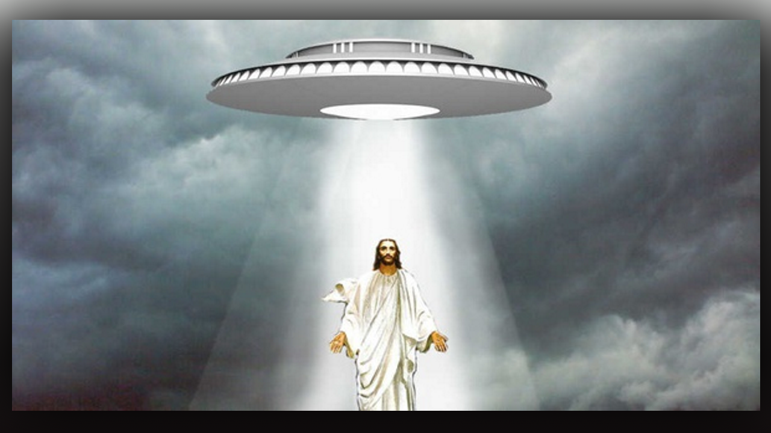
Continuing from Part 1, this is Part 2 of 3.

Jesus continued, “Everyone will be hailing these extra-terrestrials for their advanced intellect and helpfulness. There will be heated arguments even among believers that they are Christlike and holy. How will you tell them apart from Me? When they talk about loving one another, forgiving, walking in peace and freedom: when they talk about higher consciousness and spiritual dimensions: when they display healing powers and supernatural signs and wonders: when they talk about a thousand-year reign of peace; when they talk about Christ consciousness and display great dignity. How will you know if they are truly Christians, if they are saved, or if they know Me?

“If they tell you that I came from their planet to prepare the Earth for a great awakening, how will you know if that is true? What if they tell you that My brother is Lucifer and has the very same powers? Won’t the witness of their supernatural wonders convince you that it might be true, after all?

“Let Me make this plain, dear ones. It is the same old New Age doctrine wrapped in a covering of supernatural events and signs. My people do not be misled by those who are preaching light, love, healing and equality, but endorsing what you KNOW to be sin. You have all been prepared to accept gay and lesbian marriages, even to the point of thinking that changing your gender, allowing your children to change their gender in grade school is ok. How perverse can things get before you wake up to the great deception being worked right in front of your very eyes?

“Many Scientists are perplexed as to what exactly is the alien agenda. These men and women do not know the Scriptures, so they are left in the dark, wondering if they are indeed evil or good. How could anyone who created a med bed for the sick be a bad person? How could anyone who provided the plans for free energy, and simple flying cars for everyone, how could they be bad?? These are dreams come true for mankind, and that is exactly how Satan has planned it. Most will be so wowed that they will eagerly embrace, and even sign, anything fed to them, especially if they are promised healing and extended lifetimes.

“But they are sharing all these wonderful inventions - they could not be bad, or they would have destroyed us by now. These are some of the dilemmas scientists and society are finding themselves in. These things disclosed by Satan are a Trojan Horse. These amazing, miraculous scientific findings are a Trojan horse to hook you into believing in a false spirituality that will lead you into darkness and despair.

“This is a complex question, yet a simple answer is found in Isaiah 14. It is addressed to Satan or Lucifer who was considered of the highest order of angels, leading worship to My Father, until he became jealous and fell from grace:

12.How you have fallen from heaven, O Day star, son of the dawn!
You have been cut down to the ground, O destroyer of nations.
13.You said in your heart: “I will ascend to the heavens.
I will raise my throne above the stars of God.
I will sit on the Mount of Assembly, in the far reaches of the North
14.I will ascend above the tops of the clouds; I will make myself like the Highest.”

“His agenda has never changed. He still wants My creatures to worship him instead the One True and Living God. So, he has set up a generation in which he plans to seduce all mankind, and future generations to worship him. He cannot kill My creatures and still receive worship, so his agenda is to fool mankind into believing he is God, and thereby have the whole world worship him. He has set forth technology to seduce and wow you, and draw you into worshipping him, thereby accomplishing his agenda of ascending to the Throne of God on the Mount of Assembly.

Jesus continued, “Everyone will be hailing them for their advanced intellect and helpfulness. There will be heated arguments, even among believers, that they are Christlike and holy. How will you tell them apart from Me? When they talk about loving one another, forgiving, walking in peace and freedom, when they talk about higher consciousness and spiritual dimensions, when they display healing powers and supernatural signs and wonders, when they talk about a thousand year reign of peace, when they talk about Christ consciousness, and display great dignity, how will you know if they are truly Christians, if they are saved, or if they even know Me?

“If they tell you that I came from their planet to prepare the Earth for a great awakening, how will you k now if that is true? What they tell you that My brother is Lucifer and has the very same powers? Won’t the witness of their supernatural wonders convince you that this might be true after all?
It is the same old New Age doctrine wrapped in a covering of supernatural events and signs.

“My People do not be misled by those who are preaching light, love, healing and equality but endorsing what you know to be sin. That is the key. Are they endorsing things that I have taught against and that you know are sin? You have all been prepared to accept the gay and lesbian marriages even to the point of thinking that changing your gender in grade school is ok. How perverse can things get before you wake up to the great deception being worked right in front of your eyes?

“Many scientists are perplexed as to what exactly is the alien agenda. These men and women do not know the Scriptures, so they are left in the dark, wondering if they are indeed evil or good? How could anyone who created a med bed for the sick be bad? How could anyone who provided the plans for free energy, and simple flying cars for everyone, how could they be bad? These are dreams come true for mankind, and that is exactly how Satan has planned it. Most will be so wowed that they will eagerly embrace anything fed to them, especially if they are promised healing and extended life.

“But they are sharing all these wonderful inventions, they could not be bad, they would have destroyed us by now if they were bad. These are the dilemmas scientists and society are finding themselves in. These things, disclosed by Satan, are Trojan horses to hook you into believing in a false spirituality that will lead you into darkness and despair, not freedom.

“This is a complex question, but it has an amazingly simple answer, found in Isaiah 14. It is addressed to Satan or Lucifer who is considered of the highest order of angels leading worship to My Father, until he became jealous and fell from grace”.

END OF PART 2

